Hotel Reservation System

This mini project is one of the modules created for Hotel Reservation System using ABAP on SAP.

This module is for New User Login and booking a hotel till before payment.

New user login part and booking part in hotel reservation project

A)**New User Login screen**

1a)If customer clicks on ‘username availability’ push button, it will check with database table and displays the message.

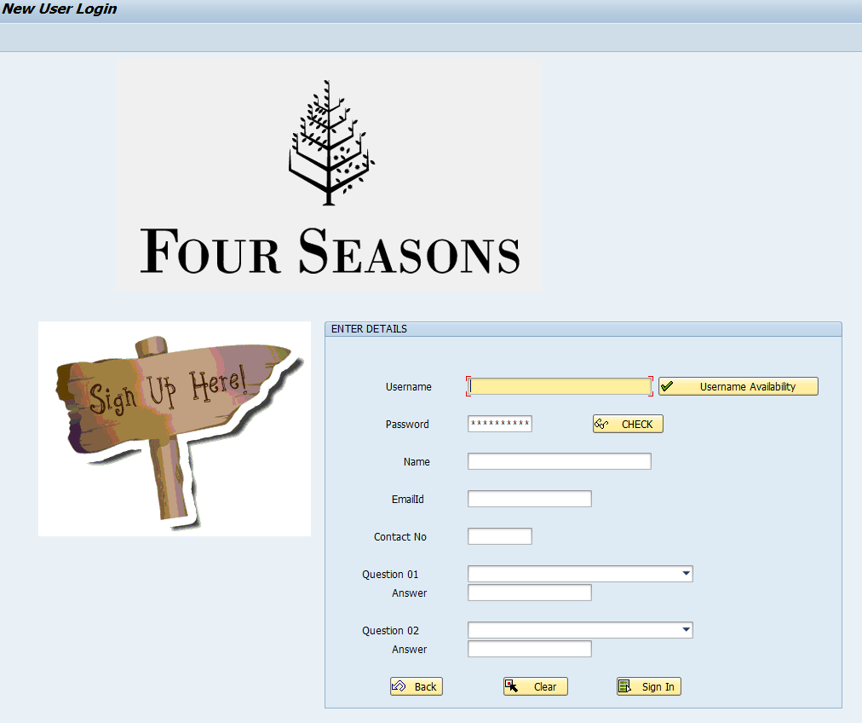

1b)If username already existing

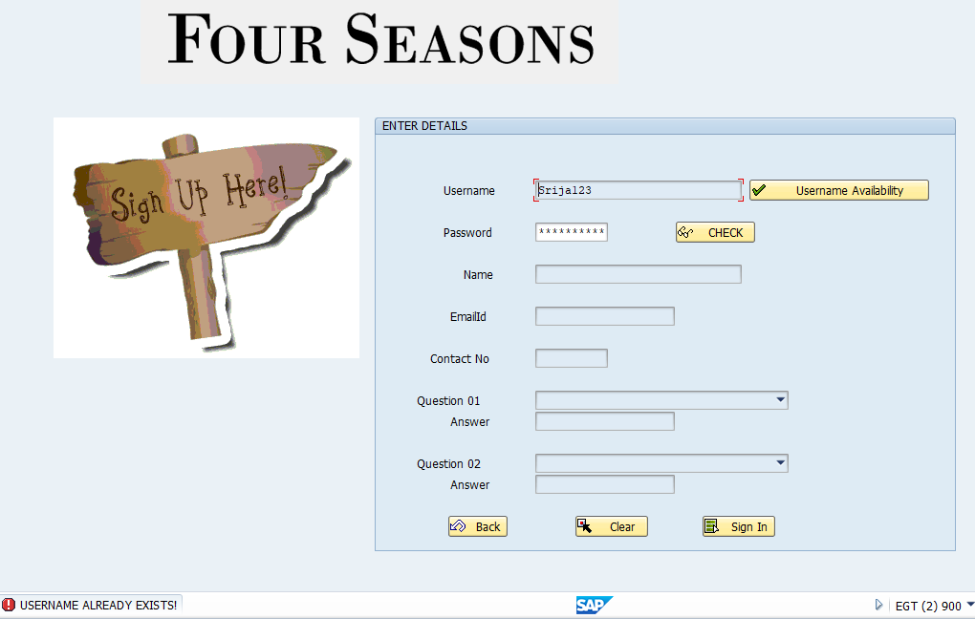

1c)If username doesn’t exists in the database table.

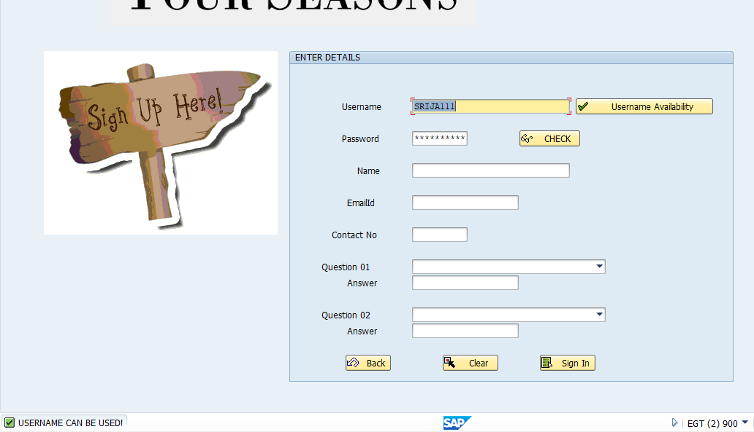

When user clicks on check button which is on the right side of password, then password which the user entered will be displayed.

2a)Before clicking on ‘check’ button

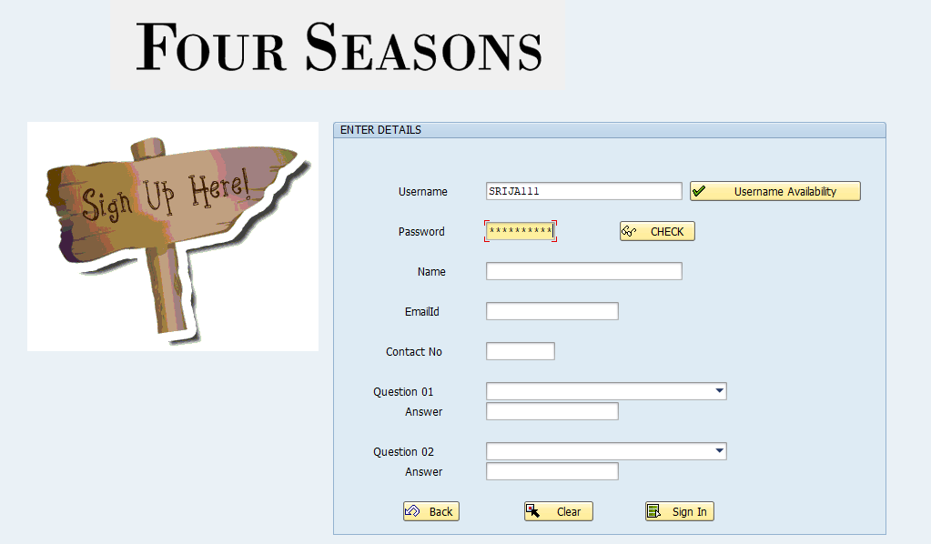

2b)After clicking on ‘check’ button.

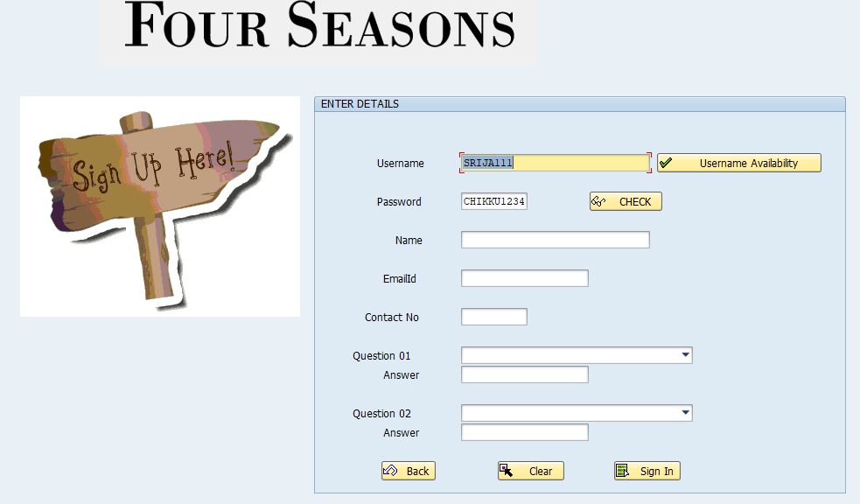

2c)Validation for email id:

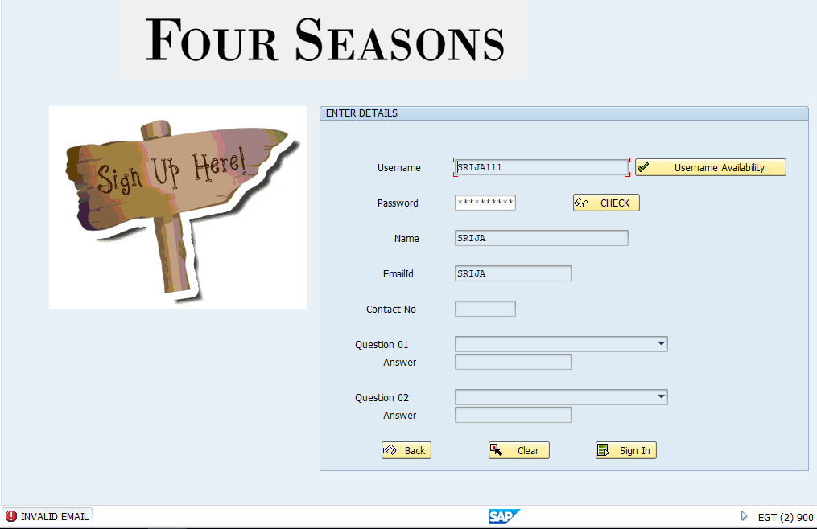

2d)Validation for mobile number:

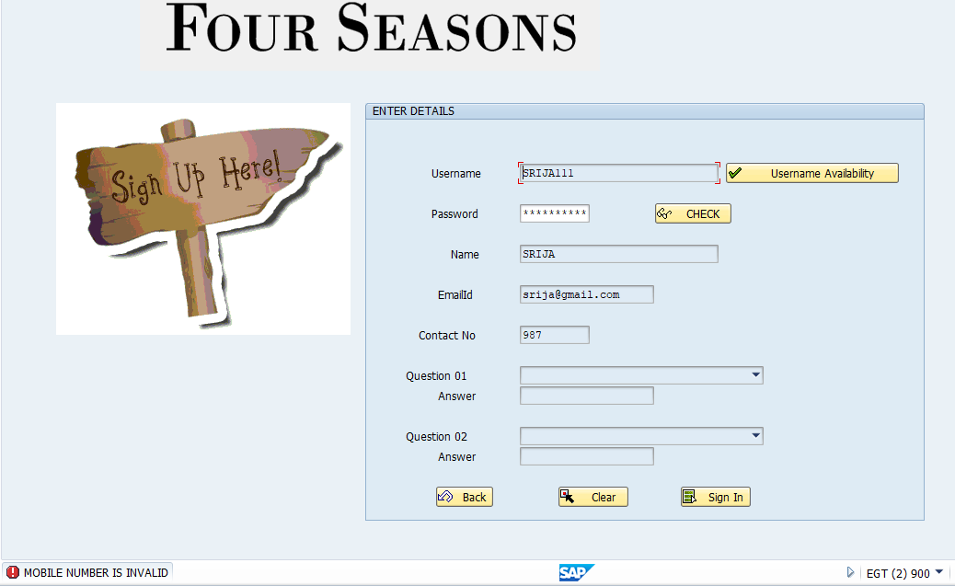

3)If user enters all the correct details,

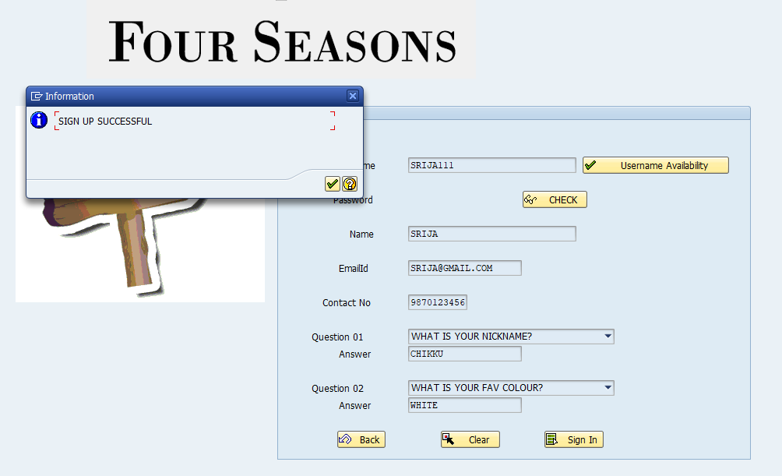

After successful signup of the user, it will go to next screen.

B)**User input screen.**

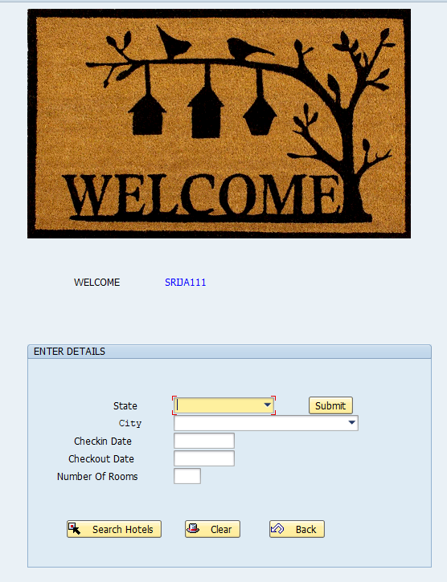

1a)If check in date and check out dates are not proper,

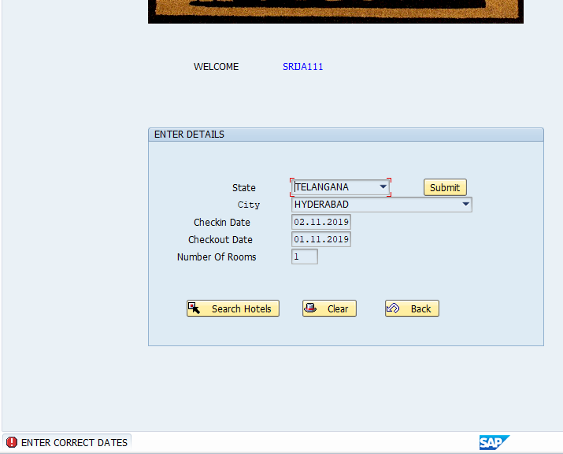

If we click on ‘clear’ ,it will clear everything.

1b)After entering proper check in and check out dates, if user clicks on search hotels, then ooalv is displayed in which all the hotels are displayed based on the filter, state and city.

C)**ALV displaying List of hotels**

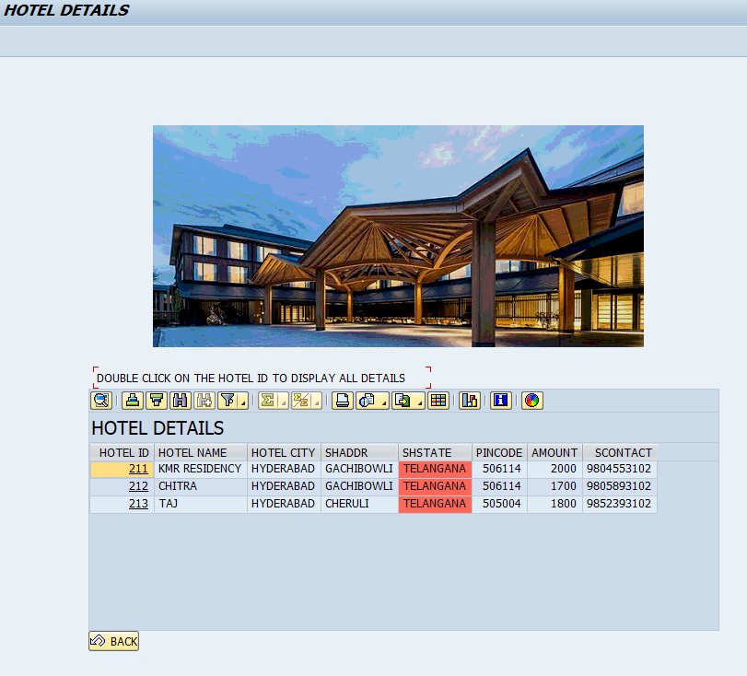

D)**Booking Details**

1a)If user double clicks on the hotel ID , then it redirects to next screen ,where

1)Booking id is generated and

2)all the hotel details and total amount payable is displayed.

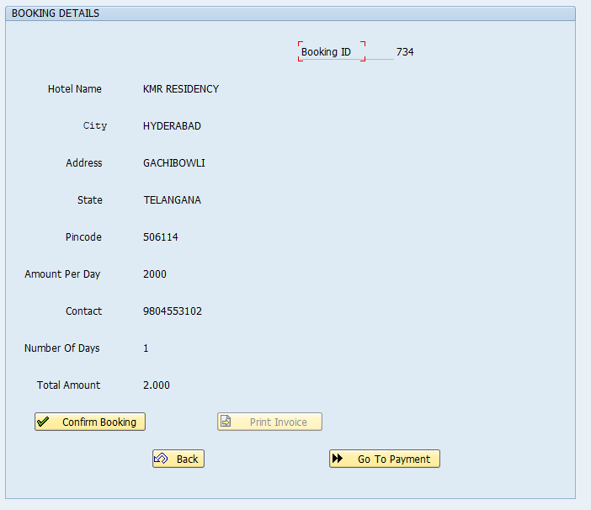

2b)If user clicks on confirm booking then booking will be confirmed and check box ‘print invoice’ is active.

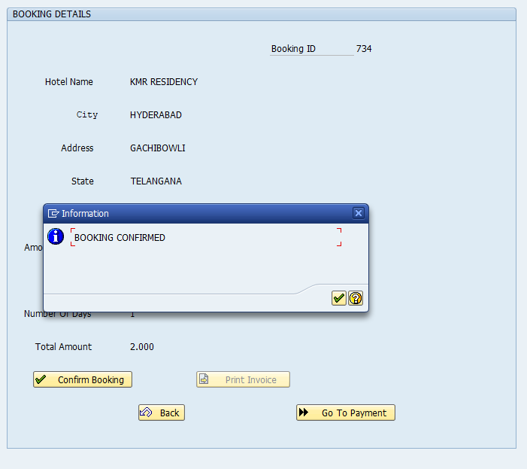

3)If user clicks on ‘print invoice’ then adobe form will be generated.  
